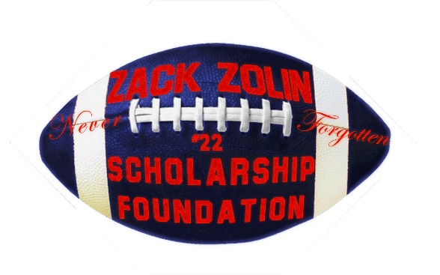

Application for Zack Zolin Scholarship
The foundation is in honor and remembrance of Zack Zolin who loved football and overcame life’s obstacles to play the game. Our mission is to provide yearly scholarship(s) to student athletes wanting to play football at the Junior college or university level.
Requirements:
- 2.5 or higher core GPA
- High school diploma, GED or Associates degree
- Reference letter from educator, counselor or mentor
- 500-1000 word essay focusing on:
  - Education goals
  - Sports goals
  - Life interests
  - Scholarship need
  - Any other information that would highlight why we should give you the scholarship
Application Deadline: xxxxxxx
Please attach your documentation listed in the requirements.
By submitting this application, you agree to the use of your picture on our website if you win the scholarship.
For questions, please send to Email: zzscholarshipfdn@gmail.com

The Zack Zolin Scholarship Foundation is a registered 501C3 public charity - EIN#81-4393512.

